Aras DevOps Studio Setup Runbook
This document gives a simple step-by-step flow to set up Package Studio. Start with the local setup first, then request the CIAM tenant, and then complete the SRE/shared services setup if required.
Refer this SI-081679 Aras DevOps Studio for Razorleaf tenant You will find all the communication and relevant details.

Source References
- Aras Package Studio 1.0 Installation Guide: https://docs.aras.com/package-studio-1-0/installation-guide/installing-aras-package-studio/1-0
- SD1407: Package Studio / Aras DevOps Studio Shared Services Infrastructure: https://kb.aras.com/gcs/a/gcs-work-instructions/SD1407/package-studio-aras-devops-studio-shared-services-infrastructure
- SD1412: Provisioning and Configuring Aras DevOps Studio Online for a Customer SDE: https://kb.aras.com/gcs/a/gcs-work-instructions/SD1412/provisioning-and-configuring-aras-devops-studio-online-for-a-customer-sde

Contacts
- Veronica Ignatyuk
- Alexander Svets

Prerequisites
- Customer CIAM tenant requested from vasil .

Component | Required Version
Infrastructure Release | release-1.1261.3
BDS Version | 1.13.1 and higher
Traefik | Included in infra release
! NOTE : DevOps Studio Online MUST NOT be provisioned until this confirmation is received from GCS.

Local Setup
Complete the local Package Studio setup first. This confirms that Package Studio can be installed and launched successfully before moving to CIAM, SDE, or shared services configuration.

  - Local Setup Steps
    - Open the customer work repository in the Local Development Environment.
    - Navigate to the AutomatedProcedures\tools folder.
To avoid future migration work, the following property in Default.Settings.include must be enabled from day one.

<property name="Import.AutoResolveItemDependency" overwrite="false" value="true" />

    - Open the packages.config file.
    - Add the Package Studio dependency to the packages list. Example package entry: Aras.PackageStudio, version 1.0.0-beta.1.10, or the approved version from the current Package Studio installation guide.
<?xml version="1.0" encoding="utf-8"?>
<packages> ...
<package id="Aras.DevOpsFramework.SaaS3" version="1.9.0.28251" />
<package id="Aras.PackageStudio" version="1.0.0-beta.2.0." />
</packages>
    - Open Windows PowerShell as Administrator.
    - Run Restore-ArasDevopsPackages -WorkRepository "<path_to_work_repository>" and confirm that the restore completes without errors.
    - Commit the packages.config update to the working branch.
    - Run BuildAndDeploy.ps1 in Windows PowerShell as Administrator.
    - Confirm that the build and deployment complete successfully without console errors.
    - Connect to the local development Innovator instance using the Administrator account.
    - Open Package Studio from the Aras Innovator table of contents and confirm that it launches successfully.

GCS Responsibility
Note: Once you get the customer's tenant ID from Vasil. You can proceed with DevOps Studio Integration to your Instance.
- Add the DevOps studion in <customer>.build.tfvars URL: razorleaf.build.tfvars - Repos
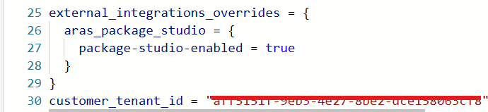
You can refer to documents to proceed further.
- Run the build_package_terraform_azureinnovator
- Run the [dev] Shared resources build slave pipeline.
- Once the pipelines get successful, you can verify the parameters are visible in
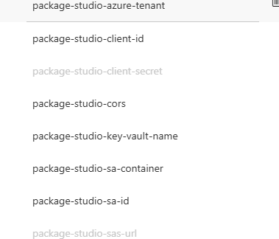
<Customers> implementation project (as i have did for Razorleaf) .
- You can proceed with running the pipeline
  - Run the CI pipeline
  - DeployInnovatorAICD pipeline

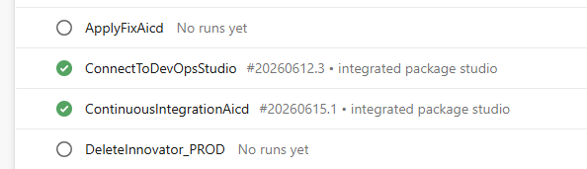
- You will proceed with running the new pipeline for ConnectToDevOpsStudio
Provide the Innovator instance release name where you want to implement
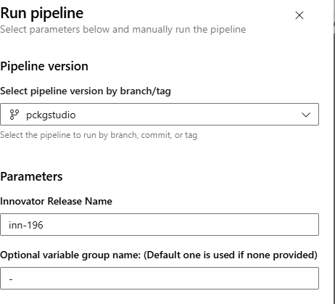
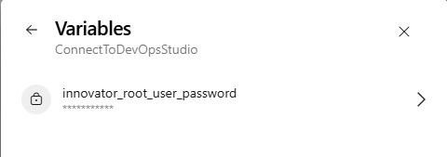
Provide the password for innovatorroot

Note: If it not added, please add manually and get the password from the
<customer>key vault -> <customer>nprd-mgmt (KeyVault)

- Once the pipeline gets successful .
- Send the customer an Welcome to Aras DevOps Studio – Your Tenant is Ready on SI.

Troubleshooting
If you ever faced this issue while running the ConnectToDevOpsStudio Pipeline .
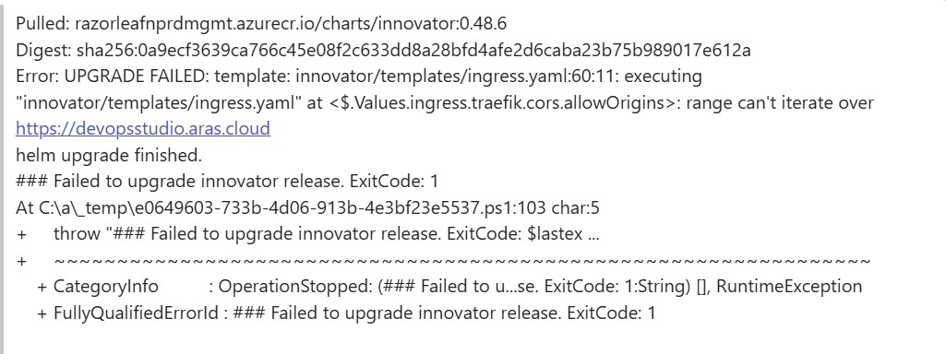
This is a bug :

Solution:
Please add customer domain to package-studio-cors variable in variable group with package studio values, so that there are two of them: https://devopsstudio.aras.cloud;
<domain used for Innovator instances> Eg:
package-studio-cors : https://devopsstudio.aras.cloud ; https://razorleaf.dev.aras-cloud.com/

